Title ( Times New Roman / 14 / Bold )

Author/s Name/s ( Times New Roman / 11 / Bold ) ( Ex. ) Abbas Hussein ^{1*}, Haider Abbas²
1- Nanotechnology and Advance Materials Research Center, University of Technology, Baghdad, Iraq
2- Department of Chemistry, Faculty of Science, University of Baghdad, Baghdad, Iraq
*Corresponding author: Email address ( Times New Roman / 9 )
Keywords:  Iraqi Journal of Nanotechnology;  Iraqi Journal of Nanotechnology;  Iraqi Journal of Nanotechnology. | Abstract  The Iraqi journal of Nanotechnology (IJN) is an international, open access, peer-reviewed journal published by Al-sibd center for research and scholarly publishing. IJN is the first journal focusing on a top-notch topics like Nanotechnology in Iraq. The journal designed to represent and make the Iraqi universities research activities internationally visible and accessible. The Iraqi journal of Nanotechnology (IJN) is an international, open access, peer-reviewed journal published by Al-sibd center for research and scholarly publishing. IJN is the first journal focusing on a top-notch topics like Nanotechnology in Iraq. The journal designed to represent and make the Iraqi universities research activities internationally visible and accessible. The Iraqi journal of Nanotechnology (IJN) is an international, open access, peer-reviewed journal published by Al-sibd center for research and scholarly publishing. IJN is the first journal focusing on a top-notch topics like Nanotechnology in Iraq. The journal designed to represent and make the Iraqi universities research activities internationally visible and accessible.

Introduction
The Iraqi journal of Nanotechnology (IJN) is an international, open access, peer-reviewed journal published by Al-sibd center for research and scholarly publishing. IJN is the first journal focusing on a top-notch topics like Nanotechnology in Iraq. The journal designed to represent and make the Iraqi universities research activities internationally visible and accessible. The Iraqi journal of Nanotechnology (IJN) is an international, open access, peer-reviewed journal published by Al-sibd center for research and scholarly publishing. IJN is the first journal focusing on a top-notch topics like Nanotechnology in Iraq. The journal designed to represent and make the Iraqi universities research activities internationally visible and accessible. The Iraqi journal of Nanotechnology (IJN) is an international, open access, peer-reviewed journal published by Al-sibd center for research and scholarly publishing. IJN is the first journal focusing on a top-notch topics like Nanotechnology in Iraq. The journal designed to represent and make the Iraqi universities research activities internationally visible and accessible. The Iraqi journal of Nanotechnology (IJN) is an international, open access, peer-reviewed journal published by Al-sibd center for research and scholarly publishing. IJN is the first journal focusing on a top-notch topics like Nanotechnology in Iraq. The journal designed to represent and make the Iraqi universities research activities internationally visible and accessible. The Iraqi journal of Nanotechnology (IJN) is an international, open access, peer-reviewed journal published by Al-sibd center for research and scholarly publishing. IJN is the first journal focusing on a top-notch topics like Nanotechnology in Iraq. The journal designed to represent and make the Iraqi universities research activities internationally visible and accessible.
The Iraqi journal of Nanotechnology (IJN) is an international, open access, peer-reviewed journal published by Al-sibd center for research and scholarly publishing. IJN is the first journal focusing on a top-notch topics like Nanotechnology in Iraq. The journal designed to represent and make the Iraqi universities research activities internationally visible and accessible. [6]. The Iraqi journal of Nanotechnology (IJN) is an international, open access, peer-reviewed journal published by Al-sibd center for research and scholarly publishing. IJN is the first journal focusing on a top-notch topics like Nanotechnology in Iraq. The journal designed to represent and make the Iraqi universities research activities internationally visible and accessible. [7]. The Iraqi journal of Nanotechnology (IJN) is an international, open access, peer-reviewed journal published by Al-sibd center for research and scholarly publishing. IJN is the first journal focusing on a top-notch topics like Nanotechnology in Iraq. The journal designed to represent and make the Iraqi universities research activities internationally visible and accessible. [8]
Experimental procedure
The Iraqi journal of Nanotechnology (IJN) is an international, open access, peer-reviewed journal published by Al-sibd center for research and scholarly publishing. IJN is the first journal focusing on a top-notch topics like Nanotechnology in Iraq. The journal designed to represent and make the Iraqi universities research activities internationally visible and accessible, the Spectro-chemical analysis substrate material is reported in Table 1.
Table 1. Spectro-chemical analysis of K417G Alloy
Ele. | Cr | Co | Mo | Si | Y | Ti | Al | Ni
Wt.% | 8.8 | 10.1 | 2.9 | - | - | 3.93 | 5.7 | Bal.
The Iraqi journal of Nanotechnology (IJN) is an international, open access, peer-reviewed journal published by Al-sibd center for research and scholarly publishing. IJN is the first journal focusing on a top-notch topics like Nanotechnology in Iraq. The journal designed to represent and make the Iraqi universities research activities internationally visible and accessible.
The Iraqi journal of Nanotechnology (IJN) is an international, open access, peer-reviewed journal published by Al-sibd center for research and scholarly publishing. IJN is the first journal focusing on a top-notch topics like Nanotechnology in Iraq. The journal designed to represent and make the Iraqi universities research activities internationally visible and accessible. A schematic illustration of the coating process is shown in Figure 1.
The Iraqi journal of Nanotechnology (IJN) is an international, open access, peer-reviewed journal published by Al-sibd center for research and scholarly publishing. IJN is the first journal focusing on a top-notch topics like Nanotechnology in Iraq. The journal designed to represent and make the Iraqi universities research activities internationally visible and accessible. The Iraqi journal of Nanotechnology (IJN) is an international, open access, peer-reviewed journal published by Al-sibd center for research and scholarly publishing. IJN is the first journal focusing on a top-notch topics like Nanotechnology in Iraq. The journal designed to represent and make the Iraqi universities research activities internationally visible and accessible. The parabolic rate constants. (Kp) of hot corrosion are calculated by the linear least square algorithm of the following equation [9]:
(W/A)² = K_{P}t (1)
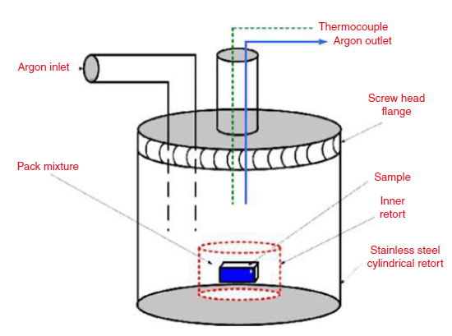
Figure 1. Pack Cementation Set-up

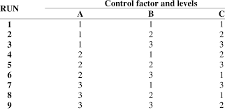
Table 2. Taguchi-Array L9

Results and discussion
The Iraqi journal of Nanotechnology (IJN) is an international, open access, peer-reviewed journal published by Al-sibd center for research and scholarly publishing. IJN is the first journal focusing on a top-notch topics like Nanotechnology in Iraq. The journal designed to represent and make the Iraqi universities research activities internationally visible and accessible.
Table 4. Parabolic rate constant (hot corrosion rate) kp (10⁻¹⁰ mg² cm⁻⁴ s⁻¹)

Exp.No | K_{P1} | K_{P2} | K_{P3}
1 | 1.33 | 1.10 | 1.01
2 | 1.24 | 1.21 | 1.91
3 | 1.43 | 0.91 | 0.79
4 | 1.35 | 1.13 | 0.80
5 | 1.11 | 1.05 | 0.75
6 | 1.02 | 1.14 | 0.97
7 | 1.27 | 1.07 | 0.73
8 | 1.92 | 0.81 | 0.88
9 | 1.30 | 0.85 | 0.76

The Iraqi journal of Nanotechnology (IJN) is an international, open access, peer-reviewed journal published by Al-sibd center for research and scholarly publishing. IJN is the first journal focusing on a top-notch topics like Nanotechnology in Iraq. The journal designed to represent and make the Iraqi universities research activities internationally visible and accessible. Hence, each response is normalized between 0 and 1. [12].
Some performance characteristics may need larger-the-better and some performance characteristics may need smaller-the-better. These two requirements use the following equations (2) and (3) respectively [13]:
X_{i} (k)= X_{i}(k)-min X_{i}(k) / max X_{i}(k) – min X_{i}(k) (2)
X_{i} (k)= max X_{i}(k)-X_{i}(k) / max X_{i}(k) – min X_{i}(k) (3)
Where, X_{i}(k) and X_{i}(k) are the sequences after the data processing and comparability sequence respectively, min X_{i}(k) is the smallest value of X_{i}(k) for the k^{th} response and max X_{i}(k) is the largest value of X_{i}(k) for the k^{t} response, k=1, 2, 3,… n.
Δ_{oi} (k)= |X_{o}* (k) – Xi* (k) (4)
Δ _{min} is the minimum deviation
Δ _{max} is the maximum deviation
In data processing, it is necessary to establish a relation between ideal and actual normalized experimental valves. It is done by calculating the grey relational coefficient which is obtained from the relation given below:
Ƹ_{i} (k) = Δmin + Ƹ Δmax / Δ_{oi} (k) + Ƹ Δmax (5)
Where:
Ƹ (k) = Grey relational coefficient
Ƹ is distinguishing coefficient fall
The parameters are given equal preference is taken as 0.5.
After obtaining the grey relational Coefficient; the grey relational grade is computed by averaging the grey relational coefficient corresponding to each performance characteristic. The overall evaluation of the multiple performance characteristics is based on the grey relational grade [14]:
ɣ_{i} = 1/n Σ^{n} Ƹ_{i} (k) (6)
where ɣ_{i} is the grey relational grade for the i^{th} experiment and n is the number of performance characteristics.
Based on the data sequence characteristics, data pre-processing have different methodologies pre started for the GRA [13].
Response or output can be converted into the comparative series according to Eq . (3) "smaller-the-better" characteristics.
Every one of the sequences of each performance characteristic after data processing utilizing Eq. (3) as shown in Table 5 normalization of performance characteristics.
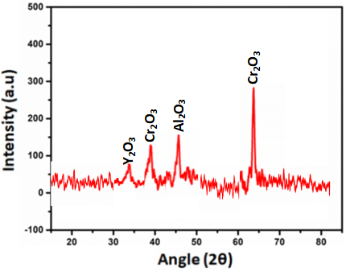
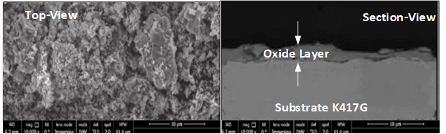
Figure 2 shows the Iraqi journal of Nanotechnology (IJN) is an international, open access, peer-reviewed journal published by Al-sibd center for research and scholarly publishing. IJN is the first journal focusing on a top-notch topics like Nanotechnology in Iraq. The journal designed to represent and make the Iraqi universities research activities internationally visible and accessible.
Figure 2. SEM/XRD Analysis for hot corroded pack coated K417G at optimum setting conditions

Conclusion
The Iraqi journal of Nanotechnology (IJN) is an international, open access, peer-reviewed journal published by Al-sibd center for research and scholarly publishing. IJN is the first journal focusing on a top-notch topics like Nanotechnology in Iraq. The journal designed to represent and make the Iraqi universities research activities internationally visible and accessible.
References
[1] R. Hejazi, “High Temperature Coatings For Industrial Gas Turbine Users,” Accessed: Aug. 02, 2020. [Online].Available: ttps://www.academia.edu/7719406/HIGH_TEMPERATURE_COATINGS_FOR_INDUSTRIAL_GAS_TURBINE_USERS.
[2] R. Drevet, C. Petitjean, N. David, L. Aranda, D. Veys-Renaux, and P. Berthod, “Aluminizing by pack cementation to protect CoSb3 from oxidation,” Mater. Chem. Phys., vol. 241, p. 122417, Feb. 2020, doi: 10.1016/j.matchemphys.2019.122417.
[3] A. Galerie, B. Pint, and D. Monceau, “High Temperature Coatings,” Oxid. Met., vol. 81, no. 1, pp. 1–1, Feb. 2014, doi: 10.1007/s11085-013-9462-3.

